17.104: a) The three possible final states are ice at a temperature below 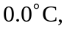 an ice-water mixture at 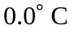or water at a temperature above 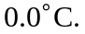 To make an educated guess at the final possibility, note that 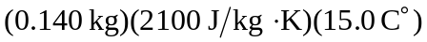 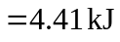 are needed to heat the ice to and 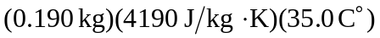 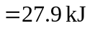 must removed to cool the water to so the water will not freeze. Melting all of the ice would require an additional 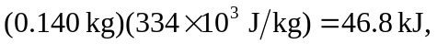 so some of the ice melts but not all; the final temperature of the system is

Considering the other possibilities would lead to contradictions, as either water at a temperature below freezing or ice at a temperature above freezing.
b) The ice will absorb 27.9 kJ of heat energy to cool the water to 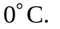 Then, 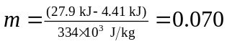 kg will be converted to water. There will be 0.070 kg of ice and 0.260 kg of water.

